

DataTier.Net Users Guide

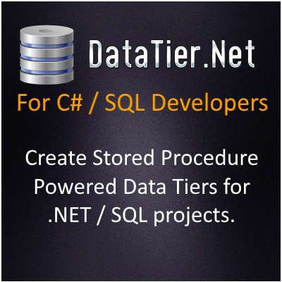

<https://github.com/DataJuggler/DataTier.Net>

**Prerequisites:**

You should read the DataTier.Net Quick Start to setup DataTier.Net before reading this document.

Database & Fields Tutorial

**Database Requirements:**

Before creating a new Data Tier.Net project you should select or create a Microsoft SQL Server database. The database you create or select may have an unlimited number of tables and views *

**Table Requirements**

A table may have an unlimited number of fields *

* limited to the SQL Server limits of course

**Primary Key (Strongly Recommended) Updated 5.15.2016**

Data Tier.Net now handles primary keys that are non-integers and not identity insert columns. The Delete, Update and Find methods will only be created for tables that contain an identity insert primary key.

**Supported Field Data Types:**

The method below is used to determine if a field is supported:

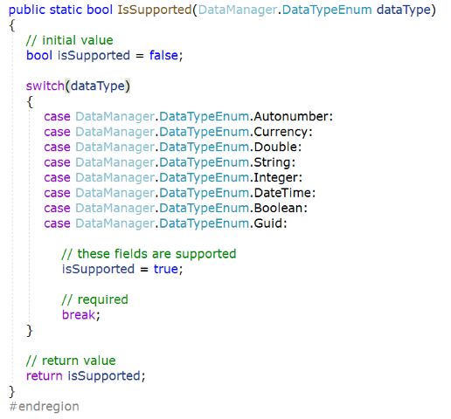

This list is using the DataManager.DataTypes enumeration which is set in the SQLDatabaseConnector.ParseDatabaseType method.

**Parse Data Type Method**

**Using the Gateway Class**

The gateway class is the bridge between your application and the Data Access Component.

The following code snipped creates a new instance of a Gateway class and loads a collection of ‘FieldSet’ objects for the selected DTNTable.

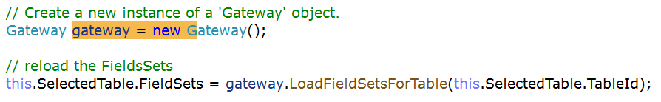

(the screen shot above is a Custom Method, but it works the same for standard methods).

**Gateway Deep Dive**

After you build your project with DataTier.Net, the standard Gateway class will contain up to 4 methods per table: Delete, Find, FetchAll, and Save.

The Delete and Find methods will only be created for tables that contain a primary key, specifically an Identity Insert (auto number) primary key.

Below is the Gateway class used in DataTier.Net to find Custom Methods for a table:

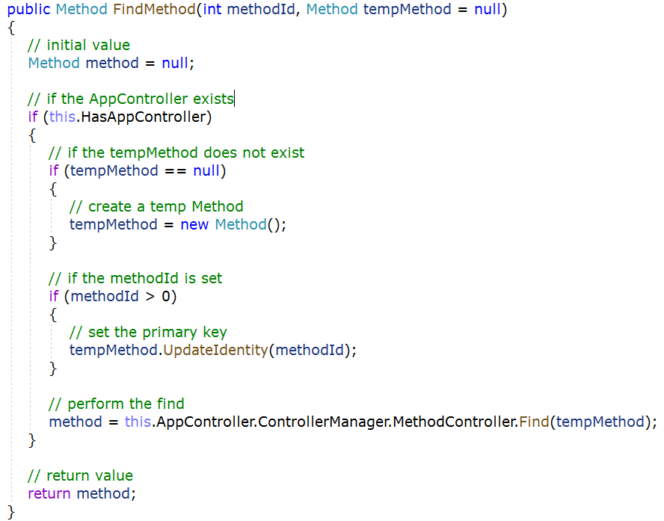

The ‘TempMethod’ object passed in is an optional parameter that is passed into the Data Access Component, where the Data Writer converts those values into SQL Parameters.

When you create a custom ‘Method’ using DataTier.Net, the custom method will set the values for this object instance, and then pass that onto the standard method in the Gateway to perform the data operation (Create, Read, Update or Delete, aka CRUD).

The following example is the LoadMethodsForTable method:

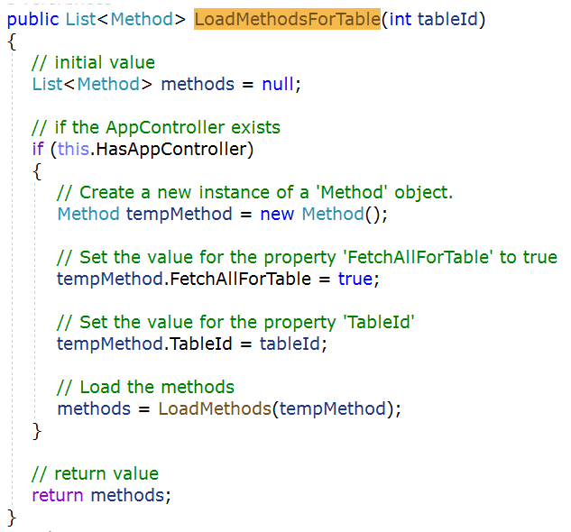

The method above is code generated via DataTier.Net. Hopefully you will agree this is more elegant than most code generated code; most human written code as well.

When I decided to rename the program DataTier.Net from RAD Studio Code Generation Toolkit, I created a control called the Data Editor Control, which I originally called the Table Editor Control. The Data Editor provides a way to designate specific tables, views or fields to exclude. Once I added the ability to create custom methods, custom field sets, custom readers and other things I realized Table Editor was not an appropriate name.

You can launch the Data Editor after you build by click the Manage Data button, which will become visible after your build completes.

**Data Editor**

Below is a screen shot of the Data Editor:

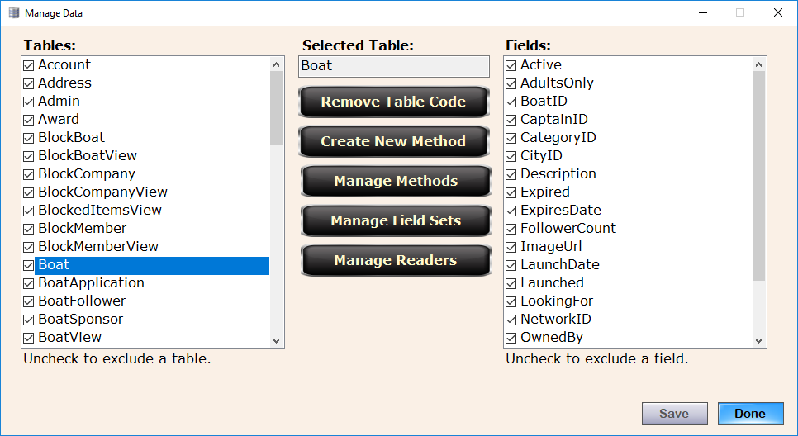

**Data Juggler.Net**

This is the engine that powers DataTier.Net, and the sample projects DB Compare and XML Mirror as well.

The class DataJuggler.Net has been tested and worked on for around 15 years. I am not stating this code is bug free by any measure, just much more tested compared to the new code in Data Editor Control.

**Database Compatibility**

DataTier.Net works well on any database I create. When I work on databases that were created by someone else, I have had to adapt the code a few times. A few years ago, I had to modify DataTier.Net to support tables at my current job, which the database contains 5 tables to handle OWIN login support:

AspNetRoles, AspNetUserClaims, AspNetUserLogins, AspNetUserRoles, AspNetUsers.

The tables above use a varchar primary key, and now DataTier.Net supports this feature. My point is, there will probably be new features needed to support more SQL Server database types.

I tried using the North Wind database once, but this database has a different database owner with tables like Sales.Reports (or something like that), and the database owner not being dbo messed up DataTier.Net. I spent a long time trying to fix this once, and just gave up as I never create database owner objects like that.

**Why the Custom Method Editor Is Needed?**

The first 10 years or so I would create custom methods by hand. This wasn’t that difficult, but I would have to go to SQL Server, alter an existing stored procedure to create one that accepts some parameter(s), and modify about 3 places manually in the code to execute a custom stored proc.

I never found this whole process too difficult, but at my day job where I inherited an Entity Framework project with years of code attached, I couldn’t just switch data tiers overnight; even if I wanted to.

**Custom Stored Procedures Are Now Updated When You Build**

Another Epic new feature in this version that accompanies Custom Methods, is that now when you rebuild your project DataTier.Net, the file stored procedures.sql will update any custom procs with ‘Update On Build’ set to true.

Maintenance was very difficult on custom procedures before this release. When new fields were added, you would have to manually update any custom procs.

**A Word About Entity Framework**

After a few years of using EF, it is hard to deny that lambda expressions can be a time saver. My biggest reason for continuing development on this project even though ‘The World’ uses EF, is the amount of SQL that an EF app executes in a production environment, compared to DataTier.Net. In DataTier.Net schema reading is only performed on a dev machine.

At my current day job, I maintain a DataTier.Net working data tier in addition to our EF one. DataTier.Net has saved me on numerous occasions because in the end, I am calling code that executes a stored procedure with DataTier.Net.

Entity Framework determines on your behalf what to save. If it gets it right, all is good. When EF gets it wrong, I found it difficult to debug on a few occasions.

**The Gateway vs Data Context**

The Gateway was not in the first version of Data Class Builder.Net, although I was manually creating one in all projects because it was easier to call this



Rather than call all the code that I showed here:



**Getting the Last Exception**

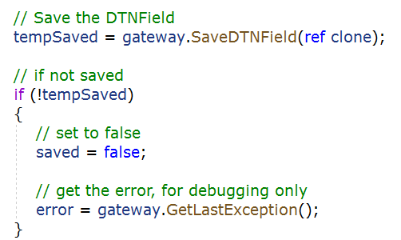

**The Gateway is More Portable**

Another advantage that I find useful, and you may or may not, is the fact that you can create an object with one instance of a Gateway and save it with another.

The disadvantage to this (to some people), is that DataTier.Net does not keep track of change tracking like EF. I toyed around with an object Serializer, and I sometimes create my own change trackers, so this is up to your personal taste.

**XML Mirror** can be used to create an ‘Original’ state of your object, and then you can create a ‘Current’ state, and if the two strings are different, your object has changed. This is demonstrated in the Custom Reader Editor in DataTier.Net.

**Entity Framework Is More Tested**

Entity Framework has been tested internally by Microsoft by tens of thousands of engineers, testers and researchers, and hundreds of thousands if not millions of developers outside of Microsoft.

As smart I think I am some days, the next day I find out something that makes me look so stupid, I have learned to buy good tasting socks for these foot in mouth situations. Hopefully soon I will not be the only person developing on DataTier.Net and it can keep improving.

A note to anyone like me that needs to keep pesky day jobs. You may be at a different stage in your career than I am, and being a conformist is probably in your own best interest. My boss is under the camp if I can solve something in a shorter amount of time, the method is less important than solving the problem. My boss is happy once their clients are happy.

My broker is EF Nuttin, and we I give advice, no one listens.

As of the time of this writing, no one has heard of DataTier.Net but me, so if your boss or client says this project needs to use EF, then EF is what you should learn to love, or at least act like you do just like I do.

Being EF is so much easier than the old way I was using RAD Studio Code Generation Toolkit, instead of just porting my old code from Code Plex over, I knew I had to step the game of DataTier.Net up a few levels to compete.

**Creating Custom Methods**

The following pages include completed screen shots, rather than a new screen shot for each step as I might do if this were a commercial product.

I do have a day job and time is my most limited resource, so please understand.

I welcome any feedback on this document and the Quick Start guide If after reading there are any areas that I do not explain clearly. It is hard to forget all the things I have learned while working on this project over the past 15 years.

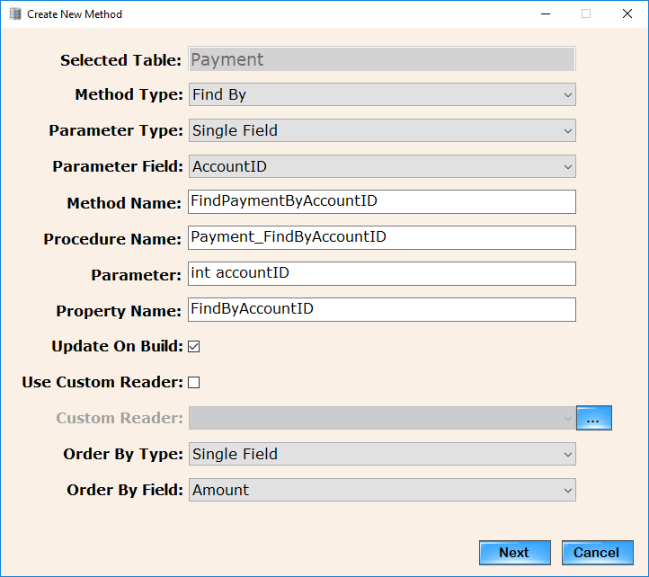

As you select the values for Method Type, Parameter Type and either a Parameter Field or Parameter Field Set, the Method Name, Procedure Name, parameter data type and the Property Name fields are completed for you.

I will admit this is not an unbreakable editor. As you select each field, if you decide you want to change anything previously selected, start over if it doesn’t behave properly. The events on this control append text onto the existing textboxes, rather than check for the previous existence and attempting to modify.

Note: I added the Parameter Type of ‘No Parameters’. I can think of few scenarios like ‘Top Selling Products’, that do not require any parameters, but

I haven’t had time to implement a ‘No Parameters’ use case yet.

A more detailed explanation of this control might help you understand how DataTier.Net works under the hood (for when something goes wrong).

**Method Type** -Find, Delete or Fetch All

**Method Name** – This is the Method Name in the Gateway. DataTier.Net fills this in for you, but you can change it

**Procedure Name** – This is the Stored Procedure Name and you may change it

**Parameter(s)** – The parameter (or parameters if you are using a Parameter Type of Field Set) contains the data type and field(s) for the gateway method. The Procedure Writer object converts the Parameters to SQL Data Types.

**Property Name** – The property name is the name of the property in the business object for your table. This is used to indicate to the Data Writer, the stored procedure name must be changed, and if there are any parameters, the DataWriter must convert them to SQL Parameters when it executes.

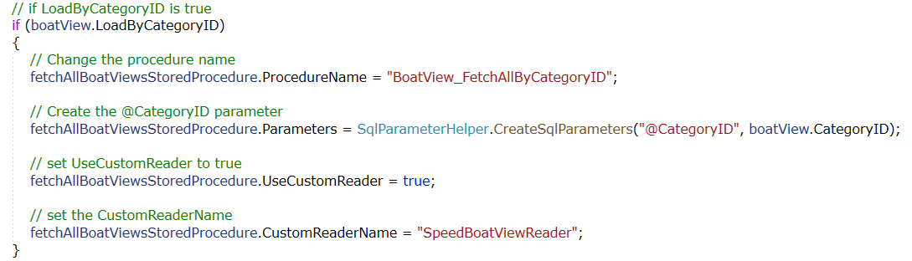

The class SQLParameterHelper allows you to create up to 4 SQL Parameters.

I will update the documentation more for the Custom Field Sets, Custom Readers and Order by as I have time.

They all work basically the same, and then you end up on the ‘Confirm Changes

Control’, which requires your authorization to modify your project.

**FieldSets**

A Fieldset is a collection of fields and there are several uses for fieldsets.

1. As a parameter list for methods
2. Used to order by two or more fields *
3. With custom readers where you only want to return a select set of fields

* You could use a field set to order by one field, but a single field OrderByType is recommended for this use case.

**Using the FieldSet Editor**

Click the Add button and give the new field set a name. Next select two or more fields. The reason two fields is required is the same functionality can be accomplished without a field set if you want to use only one field.

**Parameter Mode**

Parameter mode is used to create procedures with multiple parameters.

**Order By Mode**

Order By Mode is used to order your return results by multiple fields.

**Custom Reader Mode**

Custom Reader Mode is used to designate the fields returned in method using a custom reader.

**Order By Fields List Box**

**Update 10.10.2019: Not All My Ideas Are Good Ones.**

I throughout the first order by control because it didn’t work, and now I added another list box to allow you to arrange the order of the order by fields:

Click the name of the field to select it, and arrows appear to allow you to swap the order with a field adjacent to the selected field.

**New 9.4.2019: Descending Order Now Available**

Picture shown has the Score field currently set as Descending; check or uncheck the box to switch from ascending to descending.

The Order By Fields becomes enabled if Order By Mode is selected.

**Confirm Changes Control**

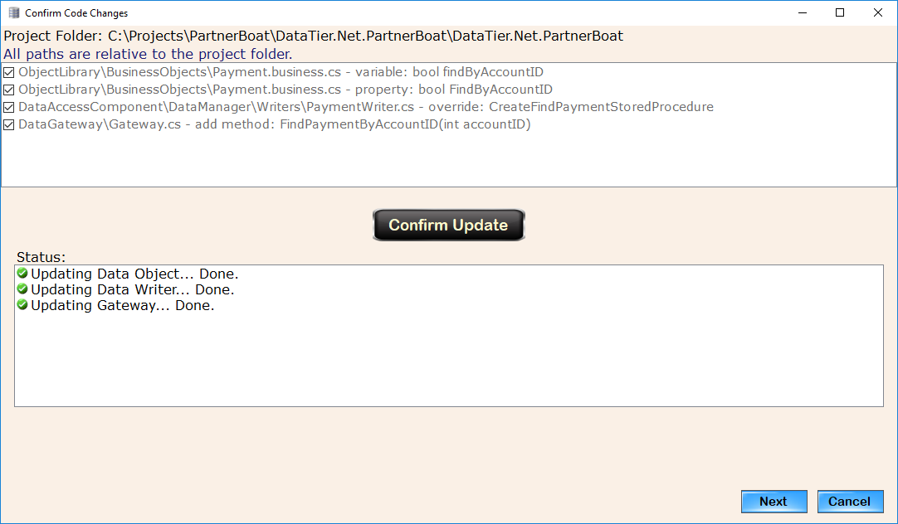

The messages shown above could be slightly different if any of the objects have already been updated, DataTier.Net will inform you of this fact. This was mostly for me during testing, but it is still useful, so I left it in.

Next you will be taken to the New Stored Procedure Editor. It is called new because there was already a Procedure Editor Control in the Project Wizard Control, but these two controls are very different.

**New Stored Procedure Editor**

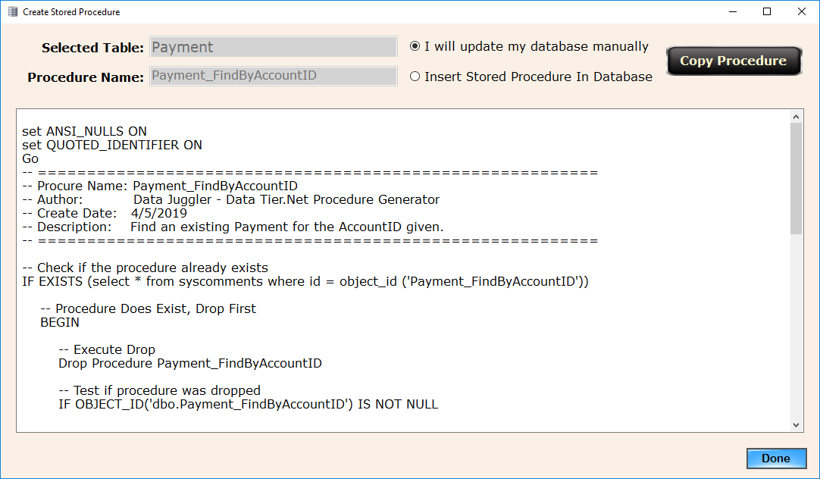

By default, you must copy the stored procedure text to your clipboard and go to SQL Server Management Studio and install it into your project’s database.

If the connection string you used to create your DataTier.Net project has permission to create and execute a stored procedure, you may choose to insert the stored procedure.

I found out while writing the C# code to create a stored procedure on SQL, you must execute the If Exists, Drop Procedure Query separately from the create, so the code executes two SQL statements here, parsed by the Go keyword.

Once your stored procedure has been installed into your database, you should be able to execute the new code in your project.

**Update Proc Permissions** (optional – if security problems exist)

As explained in the DataTier.Net Quick Start Guide, there is an optional stored procedure in the DataTier.Net.Database called UpdateProcPermissions.

I wish I had reclaimed the original author of this post to give them credit, but I forgot where I found this stored procedure. If you are experiencing any any problems executing a stored procedure, install the UpdateProcPermissions stored procedure and execute it as shown here:

Exec UpdateProcPermissions ‘[User Name]’

**Visual Studio Project Updater**

If new files were created during your build, the Visual Studio Project Updater will launch.

**Removing Table Code**

If you are anything like me, I have a lot of ideas. Some ideas turn out to be good ones, like DataTier.Net. Others are not so good. Sooner or later you end up needing to delete or rename a table. Removing a table was something I used to do manually, so table ‘[Good Idea That Fizzed]’ would stick around much longer than I wished.

Now that it is a button click, it is a lot simpler, but it is still is kind of tricky because there a couple of final steps that must be taken to finalize the removal after the button click event executes. While writing the documentation and filming the Quick Start video I messed this up, so I modified the app to launch a message box indicating the final steps that are still needed.

Step 1: Drop or rename a table in SQL Server Management Studio

Step 2. Select the Table in the Data Editor and click the Remove Table Code button.

Note: Click the Remove Table Code button while the table is still active (checked)

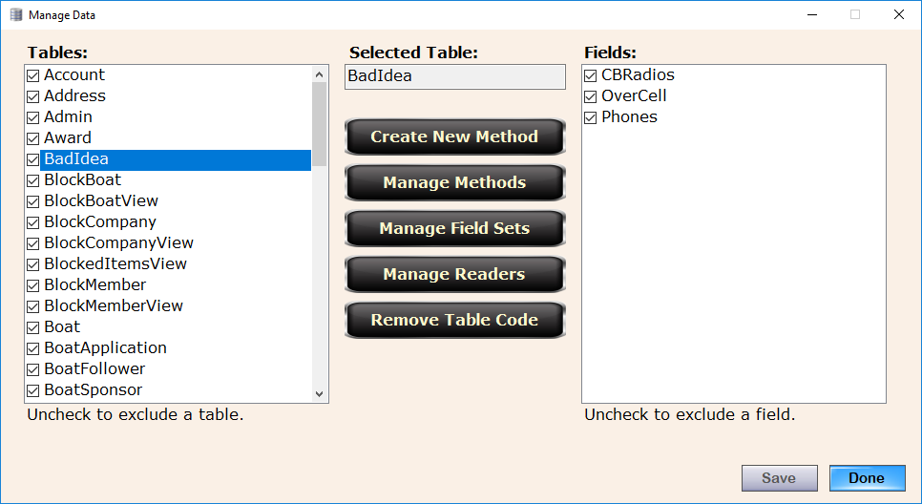

This will launch the Confirm Removal Control

**Confirm Removal Control**

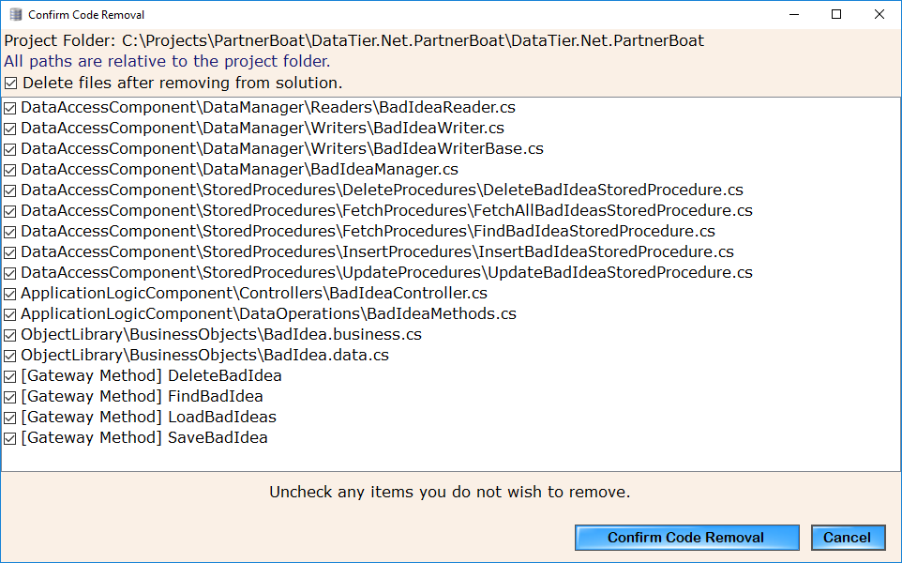

Click the Confirm Code Removal button to proceed to the next step.

This will launch the Visual Studio project updater (in remove files mode)

Step 3: Select the solution file. and each of the project names will be populated like it does when you include files after building.

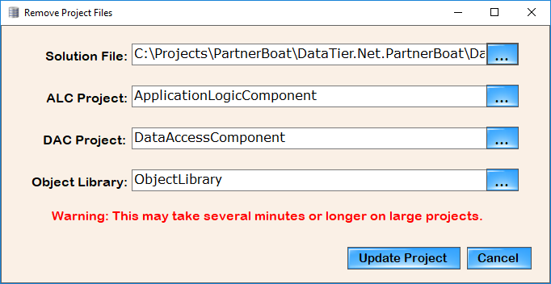

Although the warning label that states this may take several minutes is still visible in remove files mode, this usually completes in about 5 seconds for me.

After it completes you will be shown a series of back to back message boxes* that explain the final instructions on the second message box:

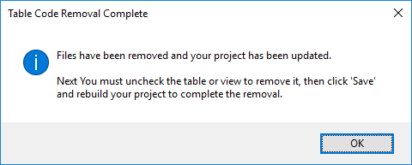

* The two message boxes are because I was in a hurry and reused already built controls without spending a few minutes to fix it. I wasn’t 100% sure if the same code that interacts with COM and performs the file inclusion would work for removal purposes. It turned out this was simple because I already had a list of files available in the Project File Manager, so all I had to do was pass in a list of files and change .add file to .remove files while in File Removal Mode.

**DataTier.Net Project Files**

This screen shot a couple of pages back illustrates the project structure of a DataTier.Net project. When I get some “magical” free time, I will build some updated documents or graphical models to better illustrate the project structure.

If I were rebuilding DataTier.Net from scratch today, I would have created this project structure with three projects instead of four. There is nothing inherently wrong with the Application Logic Component; I just wish I had written the code in the Controllers and Data Operations folders to be part of the Data Access Component.

It could still be done if other people feel that the ALC is excess baggage. Removing it “shouldn’t” be too difficult (what could go wrong?).

The more features that get added like Custom Methods and Removing Tables, the more complicated future maintenance becomes, so now is the time to sound off, or forever hold your piece.

**Troubleshooting**

One more advantage I find in DataTier.Net over Entity Framework is in the end you are writing code that calls a stored procedure. If there is a problem with the code, you can go and fix it, instead of being constrained to what you can do from outside of a Data Context.

If anything goes wrong with the building and including or removal of files, Visual Studio will notify you of the file(s) missing.

Clicking the ‘Show All Files’ button in Solution Explorer will show you if the file was created or not. You can then decide if it should or should not be included in the project.

One easy way to fix a build if something goes wrong with a table is to remove the table, build and then add it back again. and build again.. This should fix most issues unless something is really messed up.

I will be posting some new videos covering a deep dive and some new tutorials and some sample projects to cover a lot of the new features as soon as possible. I didn’t want to delay the release another week.

**Bugs** (not the handsome wascally one on the left)

I know there will be bugs in this code, so please be patient and understand that going from ‘works for me’, to works for the masses require lots of baby steps.



Today we have taken our first steps.

I will make myself as available as I can to answer all questions, but I must put my pesky day job (that pays all my bills) ahead of my hobbies. Please be patient if I do not respond right away.

If anyone ever needs ‘Premium’ support or remote training sessions for a problem you can’t solve with forums or anything else, capitalism does provide motivating mechanisms; contact me if the need ever arises.

Please subscribe to my YouTube channel. I will be adding new videos often:

<https://www.youtube.com/channel/UCaw0joqvisKr3lYJ9Pd2vHA>

**Frequently Asked Questions** (a work in progress)

**Question:**

Will Data Tier.Net work if a table does not have a primary key?

**Answer:**

Yes, but the methods for Update, Delete and Find will not be generated.

Data Tier.Net has been tested much more thoroughly on tables that do have a primary key.

**Question:** Does Data Tier.Net support composite primary keys (a primary key consisting of two or more fields)?

**Answer:**

Currently the answer is no. Data Tier.Net does have code to detect if a field has a composite primary key, but the data operation methods (find, update and delete) only work for a single primary key currently. Future updates may address this issue.

**Question:**

Does Data Tier.Net support using enumerations for integer fields?

**Answer:**

Yes. After you create a project, edit the project and click the enumerations button. Add the field name and enumeration name where they should be substituted, and when you build an integer datatype field will be created in your data tier as the enumeration name.

**Question:**

Does Data Tier.Net support Image or binary files in a database?

**Answer:**

Not at this time. At one time I had image blobs working but I had too much trouble code generating the stored procedures I decided to put this off because I do not use images in a database unless a client or employer has a requirement for this that I can’t talk them out of. My personal preferred method is to store the filename or ID in the database and retrieve the image from the file system or an Image Manager of some type. I forget the exact problem I had but it had something to do with the fact that the image field had to be last field in the select statement I think (it has been a while).

To handle this solution correctly I would code generate the table as if the image field did not exist, and then create an Image Helper to load the image or binary

data. I never made this a priority because I never had the demand.



**Ways You Can Help Support This Project** (and me)

I hope you like all the code I have shared with you. Code Plex dying was the right call by Microsoft, although at the time I didn’t realize how bad Code Plex was until I discovered GitHub and Azure DevOps.

If I had to tried to sell any of these applications, historically speaking I would not have been able to sell any, and thus the code would have died. If collectively you find this software to be of value to you, there are a few ways you can help me.

I lack the social gene that most people have, so if you are a member of Twitter, Facebook or any of these type platforms and think someone else might benefit from this code, please help me spread the word about the Data Juggler Shared Repo and all the programs in it.

**YouTube Content Creators Wanted**

If you like any of the code in the Data Juggler Shared Repo, YouTube throws my videos into a black hole because I watched half of an Alex Jones video, once. Ok twice, I admit it, but I never watched a whole episode.

Once I had a problem in Movavi, the video editor I use and recommend because the font is of a readable size for people with eyes that are a little older. I found numerous videos by people on YouTube that were not affiliated with Movavi.

That is the probably the greatest compliment I could ever receive; if someone liked one of my projects enough to make a video about it.

Your viewers will probably find it interesting, and the price is hard to beat even if they don’t like it, so you don’t have to worry about looking like a sellout.

**NFlate and my Windows Store Experience**



If anyone has ever wanted to sell an app in the Windows store and not had the pleasure of this experience, I will share just how much fun it was for me in my not so short story. This is also why I can’t use Twitter; It takes me 2,000 words to get to hello.

For several months, I tried to get NFlate converted using the Desktop Bridge (piece of junk made from Windows 95 spare parts) and I could never get my app in the store so I gave up and asked Microsoft for my money back from joining the Developer Partner Program or something like that.

I was sold again watching Build 2018; Microsoft is great at putting on conferences. 400 million Windows 10 users will buy your apps in the Windows store. Problem is now, when I was previously issued a refund, my email address I have used for 8 or so years is now blocked by this department of Microsoft due to the refund because someone thought the email address would make a good primary key.

Anyway, flash forward a little later and the Desktop Packaging Project comes out. This is beautiful and must have been made from leprechauns who mated with unicorns. It worked perfectly, and I am finally in the Windows Store!

I start yacht shopping at this point.

I am extremely bad at marketing, so I thought I would give NFlate away free for the first x number of days to let people try it and get some good reviews, word of mouth and all that.

The worst case I thought, is I am helping someone who might not see well like myself use Windows better and / or get their work done faster. I have done worse things in my life, I confess. I could tolerate sleeping on my own bed a few more nights while I give NFlate away free for a few days. I also still to this day do not know the delivery time once you order a yacht, so a free period sounded like the way to go. Not.

The very first review, some as#ho!# gives me a 1 star review and writes ‘This App No Work’.

I tried writing to this person and asking them what was wrong as politely as I could, without shouting what I wanted to, which was:

It was free. If you don’t like something free, you say thank you, and you throw it away!

If the app didn’t work, it wouldn’t be in the store. I had to deal with a Microsoft tester and make a few changes because I have a wide screen Monitor, and on a Surface or laptop NFlate didn’t display correctly.

Now if I was of lesser integrity, I would have paid some random stranger $20 to go buy this app and write a counter review, ‘This app works, that person is an un-appreciative fool’.

If you spend any time browsing folders in Windows, I feel NFlate is worth well over $5, but I admit I have not worked on NFlate more like I had planned since the bad review experience. The above said for mentioned (beep) also stopped all development on it, other than the Desktop version I run at home.

I do not want an unbiased review, but if you like my software and think $4.99 is not going to break you even if you don’t like it, I would appreciate it if someone would at least try it. I find this to be a flaw in the Windows Store. Potentially a competitor of another app (I don’t know) could savatage an app on the first review with no remedy.

In hind sight, this same person might get a statue named after him for the greater good he did for the members of the open source world.

I don’t remember this person’s name, but let’s call him Fart Face.

We can all thank Fart Face for the Data Juggler Shared Repo being in existence. Had my products been selling in the Windows Store, open source would not have been my only priority like it is now most likely.

After I put NFlate in the store I finished the Batch Image Converter and was ready to submit it as my second app. My experience with the store was so bad I just gave up because I didn’t have time to build a website or have any other way to sell it.

Fart Face doesn’t deserve all the credit, though. Had my Windows Store experience been better, this repo would probably not exist. Even the all mighty Microsoft still has room for improvement. Bye Yacht.

**Personal Note**

After 20 years of working for software companies that thought they were cool giving away free cokes, my teeth have paid the price. I currently have four front teeth missing and twice that number broken or chipped since the picture below was taken.

If you like any of the code that I have shared and can spare a few dollars or more, please visit:

<https://www.gofundme.com/teeth-a-thon>



Thanks for using DataTier.Net

Corby